Synopsis

Medal prediction of country using numerical data

Project Id: 26

Name : Tarun Purohit
Class Roll Number:71
University Roll Number : 2028880
Section and Group: P G2

Name : Shobhit Rawat
Class Roll Number: 66
University Roll Number : 2028851
Section and Group: P G2

Name : Gaurav Dubey
Class Roll Number: 44
University Roll Number : 2028719
Section and Group: P G2

Problem Description:

The Olympic Medal Prediction System is a machine learning-based project developed to predict the medal count of different countries using historical Olympic numerical data. The primary objective of this project is to analyze previous Olympic performance records and estimate future medal counts with the help of regression models and data analysis techniques.Olympic medal prediction is a challenging task because the performance of countries depends on multiple factors such as athlete participation, number of events, sports categories, historical performance trends, and overall country participation statistics. Manual prediction of medals becomes difficult due to the huge amount of Olympic data available. Machine learning helps automate this process by identifying hidden patterns and relationships within the dataset
Steps of Implementation:
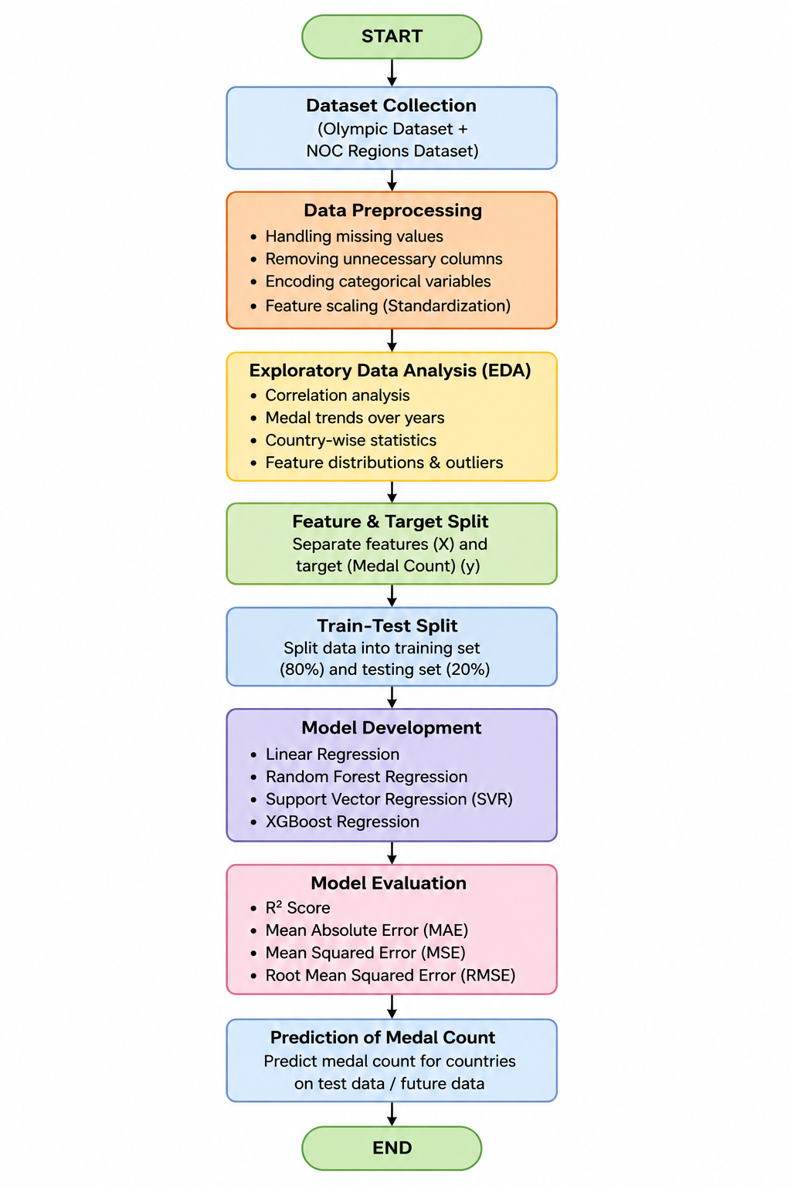

- Proposed Modules:
1. NumPy
NumPy is the foundational library for numerical computing in Python, centered around the powerful N-dimensional array object. It provides high-performance mathematical functions to operate on these arrays, making it much faster than standard Python lists. It’s the engine that powers most other data science libraries.
2. Pandas
Pandas is built on top of NumPy and introduces the DataFrame, a 2D table-like structure similar to an Excel spreadsheet. It is the go-to tool for data cleaning, manipulation, and analysis. It allows you to easily handle missing data, merge datasets, and filter information using intuitive labels.
Visualization Tools
3. Matplotlib
Matplotlib is the grandfather of Python visualization, offering a low-level interface for creating static, animated, and interactive plots. It gives you total control over every element of a figure, from line styles to axis labels. While powerful, it often requires more code to make things look good.
4. Seaborn
Seaborn is a high-level library built on Matplotlib that specializes in making beautiful, statistical graphics with less code. It integrates seamlessly with Pandas DataFrames and comes with built-in themes and color palettes. It excels at complex visualizations like heatmaps, violin plots, and time-series distributions.
Scikit-Learn (ML Workflow)
5. sklearn.preprocessing
This module is used to transform "raw" data into a format suitable for machine learning models. It includes tools for Scaling (making sure all numbers are on the same scale), Encoding (converting text labels into numbers), and handling outliers. Proper preprocessing often determines whether a model succeeds or fails.
6. sklearn.linear_model
This contains algorithms that assume a linear relationship between input variables and the target output. Its most famous members are Linear Regression (for predicting numbers) and Logistic Regression (for classification). These models are prized for being fast, easy to interpret, and highly efficient.
7. sklearn.model_selection
This module helps you organize how you train and test your AI. It includes functions like train_test_split to divide your data so you don't cheat by testing on what the model has already seen. It also features Cross-Validation and GridSearch to help find the best possible settings for your model.
8. sklearn.feature_selection
Not all data is useful; sometimes noise can confuse a model. This module provides techniques to select the most relevant variables (features) for your prediction. By removing redundant or irrelevant columns, you can reduce the complexity of your model, speed up training, and improve accuracy.

- Required topics from the subject:

1. Exploratory Data Analysis (EDA) & Descriptive Statistics
Before any prediction can happen, the data must be cleaned. This is what your plots are doing.
● Outlier Theory: Knowing how to identify and handle statistical anomalies that can skew our prediction.
● Bivariate Analysis: The study of how two variables (like "athlete count" and "total medals") interact.
2. Feature Engineering & Data Pre-processing
This is the most critical part of the code—turning raw data into "machine-readable" intelligence.
● Categorical Encoding Strategies: Specifically One-Hot Encoding. This is the process of converting qualitative data (NOC ) into a matrix(1s and 0s).
● The Dummy Variable:
● Understanding why we used drop=True to prevent redundant data from confusing the model’s logic.
● Data Cleaning: Managing missing values and data type conversion
3. Predictive Analytics (Regression Modeling)
This domain covers the "AI" part of your project—the algorithms that learn from history to predict the future.
● Linear & Non-Linear Regression: Understanding the mathematical relationship between input features and the medals.
● Supervised Learning Workflow: The process of training a model on historical data so it can generalize to new, unseen country and their medal data.
4. Model Validation & Performance Diagnostics.
● Error Quantization (MAE, RMSE): The ability to translate mathematical variance into real-world prediction of medals.
● Variance Explanation (R²): Assessing the goodness of fit to determine if the model is actually capturing the the features and analysing thke or just memorizing noise (Overfitting).
● Bias-Variance Tradeoff: Finding the balance between a model that is too simple (underfitting) and one that is too complex (overfitting).

- Platform Required:

Jupyter Notebook

- Books and Link Sources:

Let Us Python – Yashavant Kanetkar

Online Resources:
  - GeeksforGeeks – https://www.geeksforgeeks.org/
  - TutorialsPoint – https://www.tutorialspoint.com/cprogramming/index.htm
  - Stack Overflow – https://stackoverflow.com

